15.21: Fig. 15.13 plots

When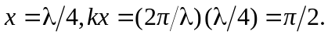
sin

The graph is shifted by 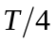 but is otherwise the same. The instantaneous power is still never negative and 